Dear Friends and Colleagues,
We are pleased to let you know that as of 1st October 2014, TeleDom Education will open the School of Innovation and the School of Hospitality. We want you to be the first to know!
TeleDom Education has been approved as a BTEC Centre of PEARSON Education, a global provider in further education and the largest awarding body in the United Kingdom.
In the 21st century only economies, companies and people that are innovative will stand the chance of being successful in the highly competitive and specialized world. Understanding the principles of researching and testing innovative ideas, developing and implementing an innovative idea are just some of the things that you will learn and be able to apply at the TeleDom School of Innovation along with top innovation professionals. The TeleDom Education offer:
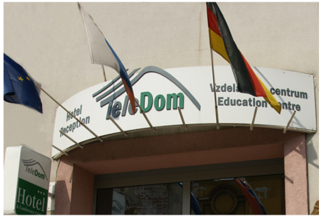  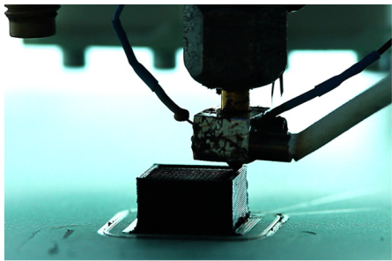 | 1) The best blend of learning methods: Education is changing with the emergence of a new type of schools, colleges and training providers, where focus is put on the practical experience. Learning in TeleDom's Real Work Environment (RWE) allows to gain not only certificated education, but the experience that is needed to outperform competition and gain good employment. The methods: Weekly web meetings with the teacher, group and 1:1 collaboration in the learning portal, practical learning (fellowships) in a RWE.  2) Internationally recognized education: Learning is not local anymore, it has become global. The fact that we offer Pearson’s global qualifications, means that you can have education that is valid in more than a 100 countries. Our Programmes consist of 16 (Certificate) to 19 (Diploma) available units to be completed within a period of 12-14 months depending on the intensity of student activity.  3) Tuition fee and job carrier: TeleDom is committed to support the best students with outstanding achievements. They can earn their tuition fee and become involved either as employees or partners in EU-wide TeleDom projects.  Your NEXT STEP: For first-time visitors please review our BTEC programmes and contacts any of our Brussels, Luxembourg and Slovakia consulting centres at: www.teledomschool.eu  General inquiries: please complete form or send Email to info@teledomschool.eu  Brussels: +32 497482111, Kosice: +421 553274400,  Luxembourg: +352 691554719, Krakow: +48 606936343  Budapest: +36 309118048

